General

* This practice test consists of 2 web pages and 1 external CSS file
* The Home page is named niagarawinetours.html
* The Gallery page is named gallery.html
* The title for both HTML files is “Niagara Wine Tours”
* All headings are purple, underlined, and letters are made uppercase using CSS
* Images are provided and are located in subdirectories inside the images directory
* The font used on the page is Tahoma, Verdana, Geneva, and sans-serif

Header

* The header of the page consists of a grid with 2 columns and 2 rows
* The header background color is moccasin
* The first cell of the grid is the width of the image. The remaining portion sizes to fill the remaining whitespace
* The social media and Book a Wine Tour Now! hyperlinks are centered in there grid cell
* When the mouse hovers over the social media links a popup displays the name of the website. Eg Twitter
* Book a Wine Tour Now! hyperlink has yellow text and border, and a green background.
* When the mouse hovers over the Book a Wine Tour Now! link the text color turns purple, the border turns green, the background turns yellow

tour_mouseout.png 

Nav

* The background color of the nav is green
* The color of the hyperlink text is yellow
* When mousing over a nav link the background for the link turns yellow, the text turns purple

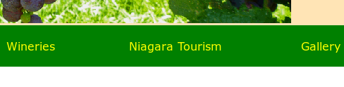 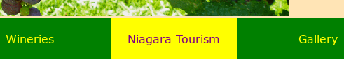

* The Home nav link points to niagarawinetours.html
* The Gallery nav link points to gallery.html
* All other hyperlinks use “#” as their path

Home Page - Main Content

* The Home page content consists of a grid with 2 columns
* The right aside consists of level 4 headings with hyperlinks below them. Hyperlinks use a “#” for their path
* The right aside has a background color of EEEEEE
* The main grid has 20 pixel gaps between grid cells
* There is whitespace between the top of the main content and the nav bar

Footer

* The footer consists of a grid with 4 columns
* Level 4 headings are used in the footer
* Text below the headings is plain text (no hyperlinks)
* The footer has a solid black border with 20 pixels of whitespace above and below it

Gallery

* The Gallery is a flexbox
* The Gallery consists of 12 images (images/images150)
* The gallery has curved corners of 10 pixels
* The flex items are centered in the flex container and have whitespace between them
* The flexbox background color is yellowgreen
* The gallery has curved corners of 10 pixels
* The right aside uses small winery images with captions placed blow them
* Caption text is 80% of the default size
* The right aside images are hyperlinks using a path of “#”
* There is whitespace between the top of the main content and the nav bar

